**Competitive Ranking System**

Vengeful Vengeance is a video game that supports both single player and competitive multiplayer. The game has an option where the players may see the single player and multiplayer statistics for themselves and for other players. On top of just displaying these statistics the application will show where the player stands amongst other players, for a specific statistic, as a percentage. The statistics shown will be for a number of groups; Individual players, a players’ character, organizations, and teams. Organizations are a collection of teams, teams are a collection of players, players can have several characters. Each team participates in a game.

An organization has many teams associated with it, and must have at least one team. A team can only belong to one organization. A team must have exactly five players associated with it. A player is allowed to have multiple characters, but must have at least one. A character can only belong to one player. This means the E-R diagram will have a one to many relationship between the Organization and Team entities. There will be a one-to-many relationship between the Team and Player entities. There will be a one-to-many relationship between the Player and Character entities. There will be a one-to-one relationship between the Character. Each of these entities will have a one-to-one relationship with its corresponding statistics entity. There will be a many to one relationship between the Team entity and the Game entity.

These groups share some statistics. The statistics that they share are number of wins, number of losses, number of games played, number of kills, number of deaths, most won map, accuracy, shots fired, shots missed, and shots hit. For each group, most of these statistics are an aggregate of the groups they are a parent of. So the number of wins, losses, deaths, shots fired, shots hit, and shots missed for an organization will be the sum of the respective statistic for each of its teams. Likewise, the number of kills, deaths, shots fired, shots hit, and shots missed for each team will be the sum of the respective statistic for each of the teams’ players. A players’ character records all the same statistics as a player, but has no effect on the standing a player has within a team and as a result does not reflect on the statistics of the player.

**Entity Characteristics**

Each group will have its own statistics entity. Each entity will have an ID that is a foreign key to the entity it is associated with. The statistics entities are CharacterStats, PlayerStats, TeamStats, and OrgStats.

The characteristics for CharacterStats are Rank, ShotsFired, Hits, Misses, Kills, Deaths, and CharID. All of which are integers. CharID is a foreign key that references the Characters entity. The characteristics for PlayerStats are Rank as an int, CreateDate as a date, and PlayerID as an int. PlayerID is a foreign key that references the Player entity. The characteristics for the TeamStats entity are Rank as an int, MatchesLost as an int, MatchesWon as an int, and TeamID as an int. TeamID is a foreign key that references the Team entity. The characteristics for OrgStats are Rank as an int, CreateDate as a date, and OrgID as an int. OrgID is a foreign key that references the Organization entity.

The game records a number of characteristics about a character; a unique identifier (a primary key), the name of the character, the class of the character, the rank of the character, and the identifier of the player the character belongs to (a foreign key).

There are also several characteristics recorded about a player; a unique identifier (a primary key), the team the player belongs to (a foreign key) and the email the person used to create the player.

The game will record a few characteristics about a team; a unique identifier (a primary key), the team name, the organization that the team belongs to (a foreign key).

The game will also record a couple of characteristics about an organization; a unique identifier (a primary key) and the number of teams currently in the organization.

The characteristics of the game entity will be the id for both teams playing against each other and the id of the team that team the match. The team ids will be a foreign key that references the team entity. This is a weak entity because it relies on the information gathered from the team entity.

Many of the queries that the application will use will be select queries and create queries. The create queries will create all of the entities/tables that were previously stated. Most of the select queries will be used to populate the statistics page of the game. Other select queries will be used to populate the tables for the organization and team statistics. These queries will also be aggregate queries since each statistic, besides the one for a character, are sums of the entities related to it. An organizations’ statistics are the sum of the teams that belong to that organization.

**E-R Diagram Description**

In the E-R Diagram below the cardinalities are shown with an arrow pointing towards the entity in the relationship that has a “many” cardinality. A one-to-one relationship is show with a line segment and a many-to-many relationship is show with a double arrow. As previously stated, the one-to-one relationships are Player Generates PlayerStats, Character Generates CharacterStats, Team Generates TeamStats, and Organization Generates OrgStats.

The participation constraints are shown with a double line. For example, a character must belong to a player so there is a double line from the character entity, a character must have CharacterStats, a Player must have PlayerStats, a Team must have TeamStats, and an Organization must have OrgStats.

The different types of attributes used are int, varchar, and date. All player id, org id , team id, and char id are int. Character name, team name, and organization name are varchar. Player creation date and Organization creation date are both of type date.

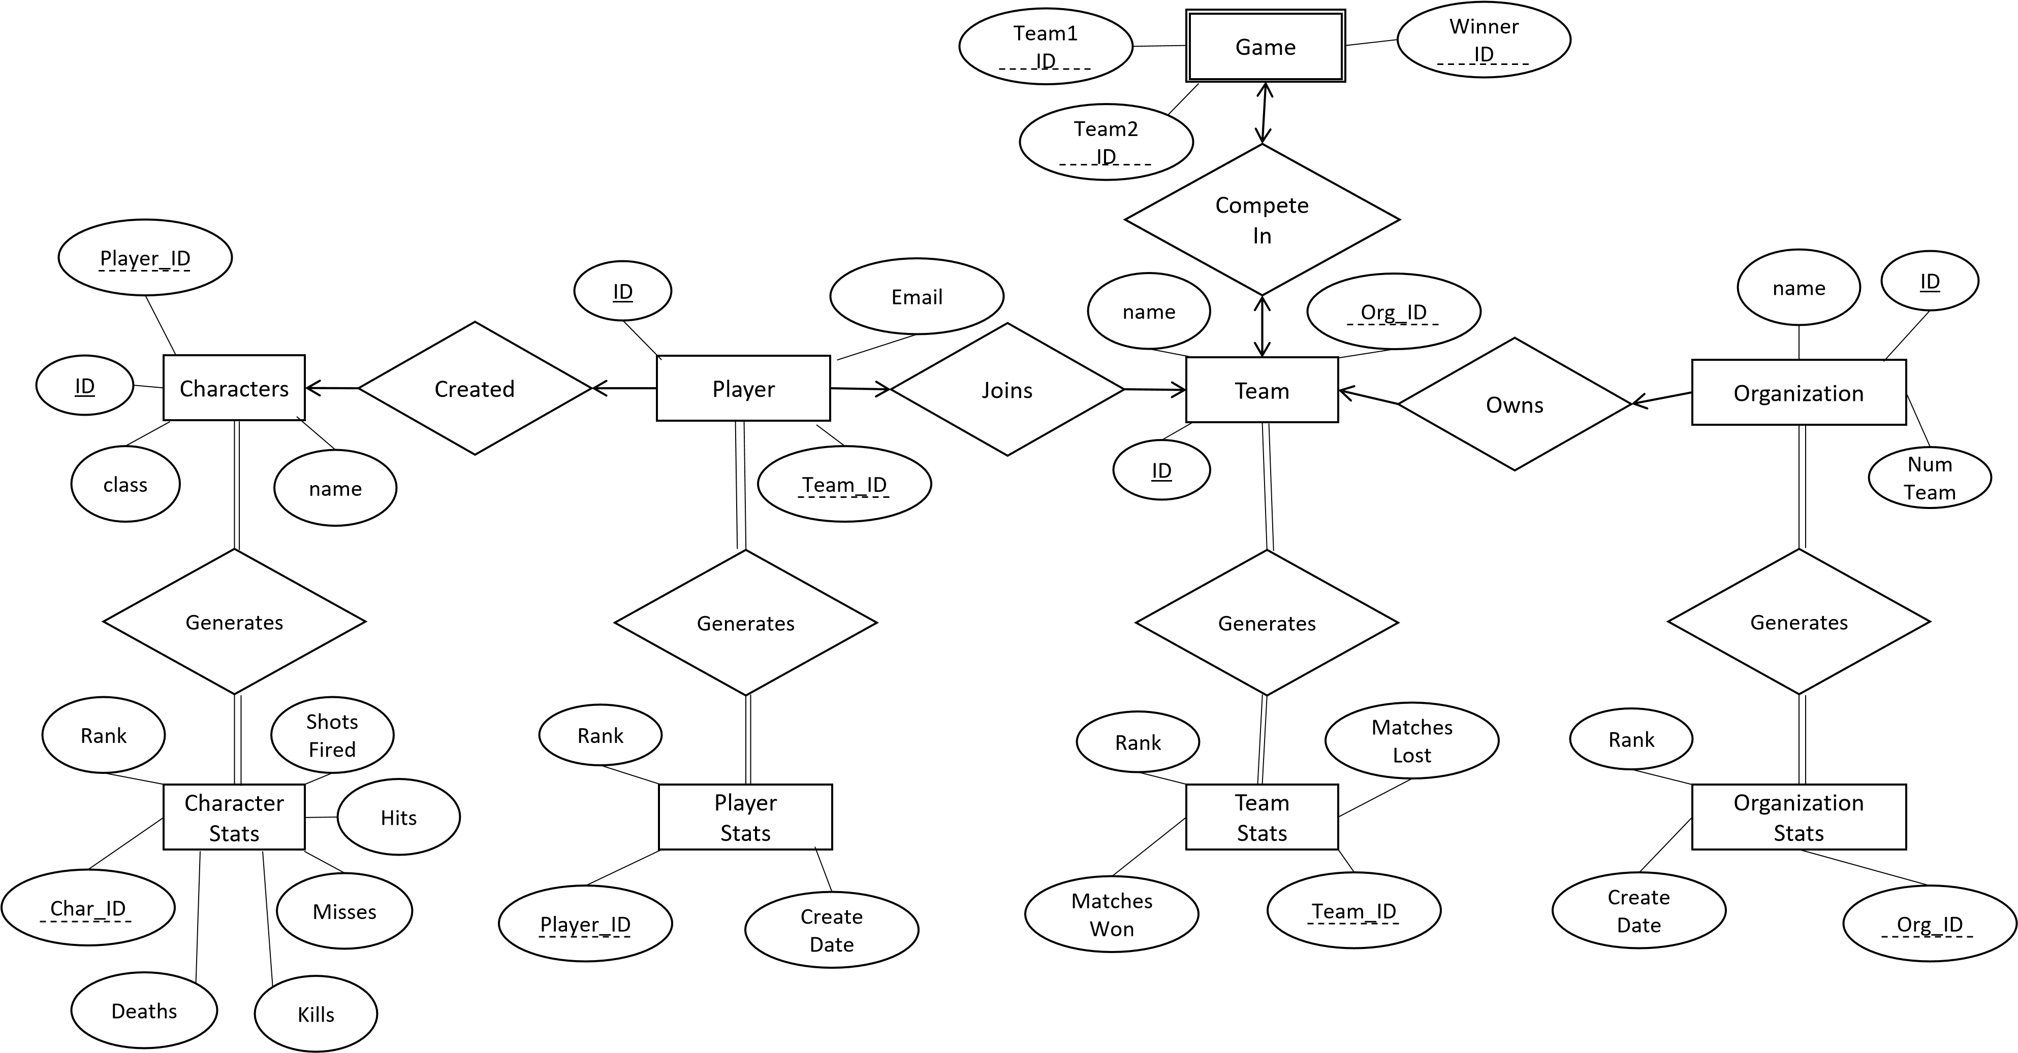

**SQL specification**

create table Organization (

ID int primary key,

Name varchar(50),

NumOfTeams int

);

create table Team (

ID int primary key,

Name varchar(50),

OrgID int,

constraint fk_team foreign key (OrgID)

references organization(ID)

);

create table Player (

ID int key,

Email varchar(50),

TeamID int,

constraint fk_player foreign key (TeamID)

references team(ID)

);

create table OrgStats (

Rank int,

CreateDate date,

OrgID int,

constraint fk_stats foreign key (OrgID)

references organization(ID)

);

create table TeamStats (

Rank int,

MatchesWon int,

MatchesLost int,

TeamID int,

constraint fk_team foreign key (teamID)

references team(ID)

);

create table PlayerStats (

Rank int,

CreateDate date,

PlayerID int,

constraint fk_player foreign key (PlayerID)

references player(ID)

);

create table Characters (

ID int primary key,

Name varchar(50),

class varchar(15),

PlayerID int,

constraint fk_player foreign key (PlayerID)

references player(ID)

);

create table CharacterStats(

Rank int,

ShotsFired int,

Hits int,

Misses int,

Kills int,

Deaths int,

CharID int,

constraint fk_char foreign key (charID)

references characters(ID)

);

create table Game (

team1ID int,

Team2ID int,

WinnerID int,

constraint fk_team foreign key (team1ID)

references team(ID)

);

**Sample Table Instances**

Organization

|  |  |  |
| --- | --- | --- |
| 1523 | Funyuns | 3 |
| 123 | Beakers | 2 |

Team

|  |  |  |
| --- | --- | --- |
| 1 | Bearclaw | 1523 |
| 53 | Chompies | 1523 |
| 2 | Munsters | 123 |

Player

|  |  |  |
| --- | --- | --- |
| 1 | [Test.mail@testmail.com](mailto:Test.mail@testmail.com) | 53 |
| 2 | [Mail.test@testmail.com](mailto:Mail.test@testmail.com) | 53 |
| 656 | [test@test.com](mailto:test@test.com) | null |

OrgStats

|  |  |  |
| --- | --- | --- |
| 1 | 04/15/2016 | 1523 |
| 1872 | 08/20/2016 | 123 |
|  |  |  |

TeamStats

|  |  |  |  |
| --- | --- | --- | --- |
| 1 | 500 | 433 | 53 |
| 2 | 499 | 450 | 2 |
| 3 | 495 | 400 | 1 |

PlayerStats

|  |  |  |
| --- | --- | --- |
| 1 | 04/15/2016 | 656 |
| 2 | 8/22/2016 | 1 |
| 3 | 8/22/2016 | 2 |

Characters

|  |  |  |  |
| --- | --- | --- | --- |
| 1 | FakeName | Medic | 656 |
| 2 | FantasyName | Support | 656 |
| 654 | BirBigs | Attack | 1 |
| 655 | Biggles | Sniper | 1 |

CharacterStats

|  |  |  |  |  |  |  |
| --- | --- | --- | --- | --- | --- | --- |
| 500 | 15235 | 1000 | 14235 | 900 | 957 |  |
| 1 | 284637 | 284637 | 0 | 284637 | 0 |  |

Game

|  |  |  |
| --- | --- | --- |
| 1 | 2 | 1 |
| 2 | 3 | 3 |

**Tables Created in Database**

